ACCOMPLISHMENT REPORT
June 8 – June 30, 2026

Name of Employee : BENJOMARK F. ANDOY
Position : Research Assistant

DATE | DAY | ACTUAL ACCOMPLISHMENT
June 8, 2026 | Monday | - First day: installed the required software and set up the development tools for the project.
June 9, 2026 | Tuesday | - Completed the welcome, login, and account-access flow with validation and user feedback.
June 10, 2026 | Wednesday | - Built Farmer and Buyer registration with form validation and successful account routing.
June 11, 2026 | Thursday | - Added role-based route guards so users access only their assigned screens.
June 15, 2026 | Monday | Built the Buyer dashboard with banners, categories, search, filters, and responsive product results.
June 16, 2026 | Tuesday | - Created Buyer product and farmer browsing cards with availability, ratings, and summaries.
June 17, 2026 | Wednesday | Built farmer shop views with profiles, filters, product tabs, and sold-product indicators.
June 18, 2026 | Thursday | Enhanced product details with images, seller data, pricing, quantity, reviews, and availability.
June 22, 2026 | Monday | - Implemented the Buyer basket with item selection, quantity controls, totals, and checkout access.
June 23, 2026 | Tuesday | Completed checkout with order summaries, delivery details, payment selection, and confirmation.
June 24, 2026 | Wednesday | Built Buyer reservations and order tracking with status views, delivery tracking, and feedback.
June 25, 2026 | Thursday | - Improved notifications with order updates, read controls, and an animated list.
June 26, 2026 | Friday | - Completed Buyer messaging with conversation cards, unread counts, chat views, and composer actions.
June 29, 2026 | Monday | - Developed the Farmer dashboard for product management, details, and sold-status display.
June 30, 2026 | Friday | - Implemented the add-product form with media selection, validation, and feedback.

Prepared by:

Benjomark F. Andoy
Research Assistant

Noted by:

CHRISTINE W. PITOS
Project/Study Leader

Conforme:

Engr. MELIZANDE S. URIARTE
Head, Research & Innovation

Approved:

IVY M ORCULLO, PHD
OIC – Campus Director

Documentation

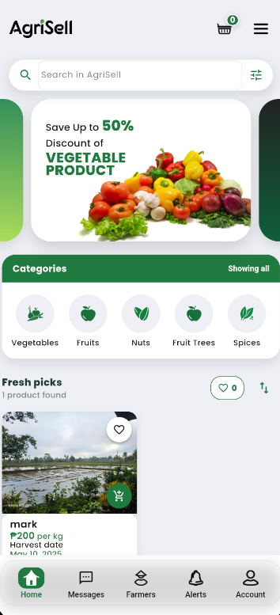
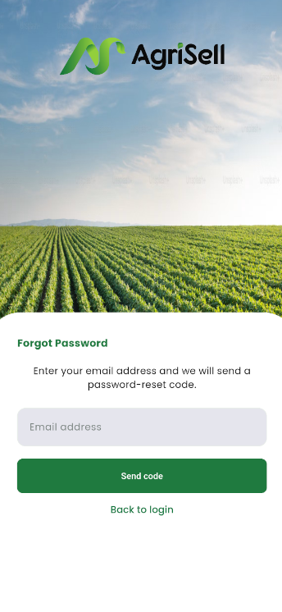
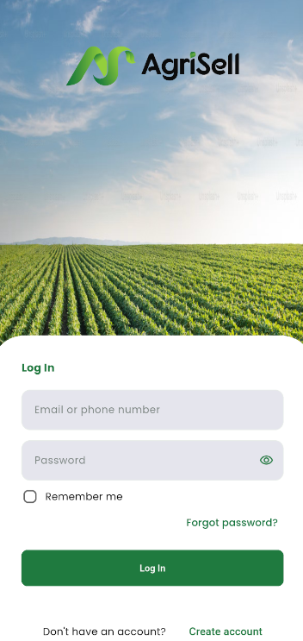
Home screen
Forgot Password screen
Login screen

The Login screen allows users to enter their email or phone number and password. The eye icon shows the password, “Remember me” keeps the account signed in, “Forgot password?” recovers the account, and “Create account” registers a new user.
The Home screen lets users search, filter, and browse products by category. The heart saves products as favorites, the cart button adds products to the cart, and the menu provides more options.
The Forgot Password screen lets users enter their registered email. “Send code” sends a recovery code, while “Back to login” returns to the Login screen.

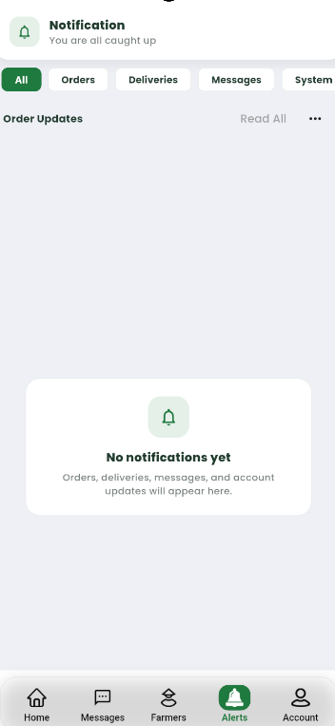
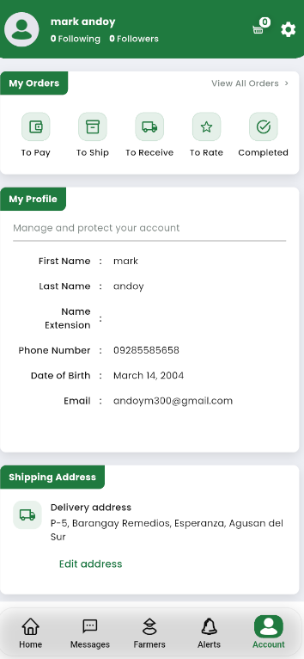
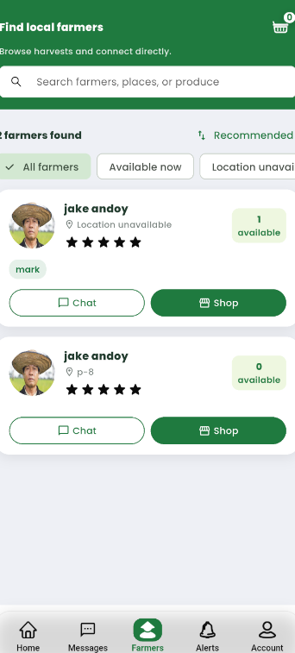
Farmers screen
Notification screen
The Farmers screen allows users to search and filter local farmers. The “Chat” button contacts a farmer, while “Shop” opens their available products.
The Notification screen shows updates about orders, deliveries, messages, and the system. Users can filter notifications or mark all of them as read.
The Account screen displays the user’s profile, shipping address, and order statuses. Users can view orders, open settings, and edit their delivery address.
Account screen

